File aspx

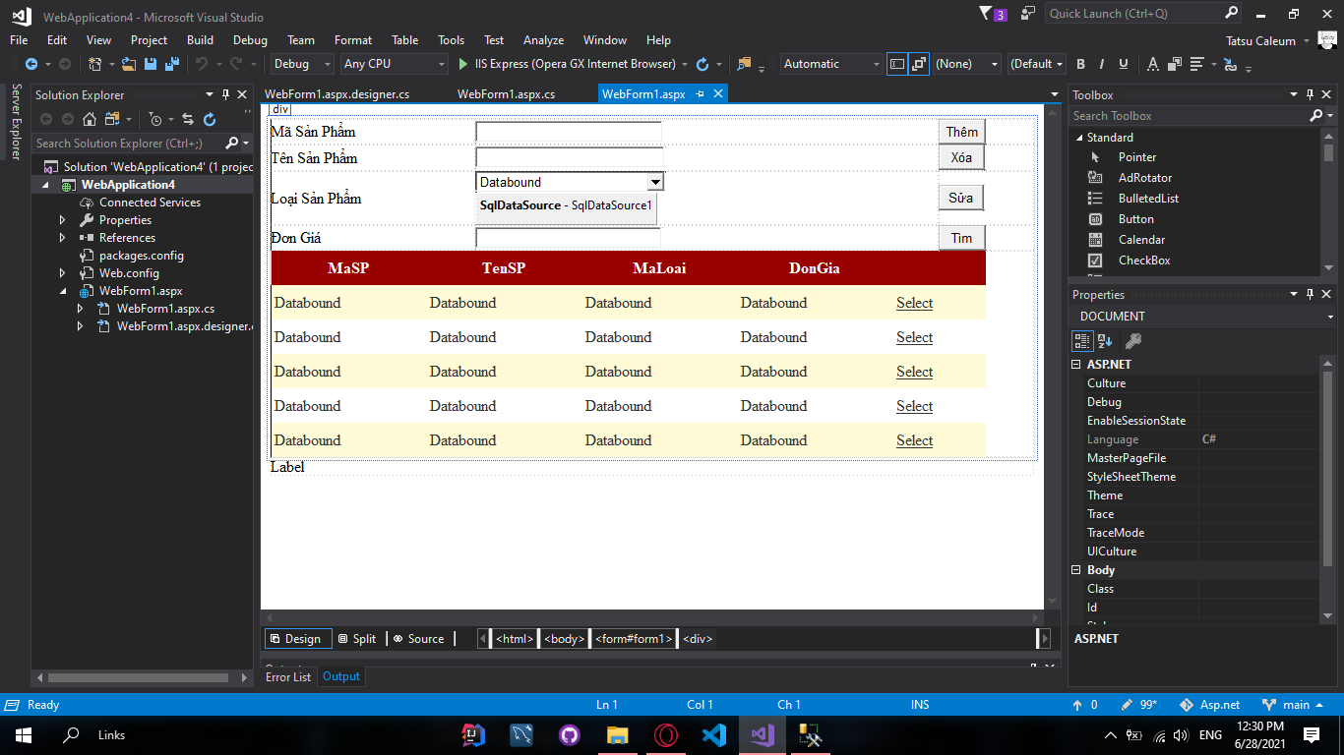

<%@ Page Language="C#" AutoEventWireup="true" CodeBehind="WebForm1.aspx.cs" Inherits="WebApplication4.WebForm1" %>

<!DOCTYPE html>

<html xmlns="http://www.w3.org/1999/xhtml">

<head runat="server">

<title></title>

<style type="text/css">

.auto-style1 {

width: 100%;

height: 197px;

}

.auto-style2 {

width: 208px;

}

.auto-style3 {

width: 471px;

}

.auto-style4 {

margin-bottom: 1px;

}

</style>

</head>

<body>

<form id="form1" runat="server">

<div>

<table cellpadding="0" cellspacing="0" class="auto-style1">

<tr>

<td class="auto-style2">

<asp:Label ID="Label1" runat="server" Text="Mã Sản Phẩm"></asp:Label>

</td>

<td class="auto-style3">

<asp:TextBox ID="TextBox1" runat="server" Width="183px"></asp:TextBox>

</td>

<td>

<asp:Button ID="Button1" runat="server" Text="Thêm" OnClick="Button1_Click1" />

</td>

</tr>

<tr>

<td class="auto-style2">

<asp:Label ID="Label2" runat="server" Text="Tên Sản Phẩm"></asp:Label>

</td>

<td class="auto-style3">

<asp:TextBox ID="TextBox2" runat="server" Width="185px"></asp:TextBox>

</td>

<td>

<asp:Button ID="Button2" runat="server" CssClass="auto-style4" Text="Xóa" Width="47px" OnClick="Button2_Click" />

</td>

</tr>

<tr>

<td class="auto-style2">

<asp:Label ID="Label3" runat="server" Text="Loại Sản Phẩm"></asp:Label>

</td>

<td class="auto-style3">

<asp:DropDownList ID="DropDownList1" runat="server" Height="50px" Width="193px" DataSourceID="SqlDataSource1" DataTextField="TenLoai" DataValueField="MaLoai">

</asp:DropDownList>

<asp:SqlDataSource ID="SqlDataSource1" runat="server" ConnectionString="<%$ ConnectionStrings:QLBanHangConnectionString %>" SelectCommand="SELECT * FROM [LoaiSP]"></asp:SqlDataSource>

</td>

<td>

<asp:Button ID="Button3" runat="server" OnClick="Button3_Click" Text="Sửa" Width="46px" />

</td>

</tr>

<tr>

<td class="auto-style2">

<asp:Label ID="Label4" runat="server" Text="Đơn Giá"></asp:Label>

</td>

<td class="auto-style3">

<asp:TextBox ID="TextBox4" runat="server" Width="182px"></asp:TextBox>

</td>

<td>

<asp:Button ID="Button4" runat="server" Text="Tìm" Width="48px" OnClick="Button4_Click" />

</td>

</tr>

<tr>

<td colspan="3">

<asp:GridView ID="GridView1" runat="server" AutoGenerateColumns="False" CellPadding="4" ForeColor="#333333" GridLines="None" Height="210px" Width="727px" OnRowCommand="GridView1_RowCommand">

<AlternatingRowStyle BackColor="White" />

<Columns>

<asp:BoundField DataField="MaSP" HeaderText="MaSP" ReadOnly="True" SortExpression="MaSP" />

<asp:BoundField DataField="TenSP" HeaderText="TenSP" SortExpression="TenSP" />

<asp:BoundField DataField="MaLoai" HeaderText="MaLoai" SortExpression="MaLoai" />

<asp:BoundField DataField="DonGia" HeaderText="DonGia" SortExpression="DonGia" />

<asp:CommandField SelectText="Select" ShowSelectButton="True" />

</Columns>

<FooterStyle BackColor="#990000" Font-Bold="True" ForeColor="White" />

<HeaderStyle BackColor="#990000" Font-Bold="True" ForeColor="White" />

<PagerStyle BackColor="#FFCC66" ForeColor="#333333" HorizontalAlign="Center" />

<RowStyle BackColor="#FFFBD6" ForeColor="#333333" />

<SelectedRowStyle BackColor="#FFCC66" Font-Bold="True" ForeColor="Navy" />

<SortedAscendingCellStyle BackColor="#FDF5AC" />

<SortedAscendingHeaderStyle BackColor="#4D0000" />

<SortedDescendingCellStyle BackColor="#FCF6C0" />

<SortedDescendingHeaderStyle BackColor="#820000" />

</asp:GridView>

</td>

</tr>

</table>

</div>

<asp:Label ID="Label5" runat="server" Text="Label"></asp:Label>

</form>

</body>

</html>

File aspx.cs

using System;

using System.Collections.Generic;

using System.Data;

using System.Data.SqlClient;

using System.Linq;

using System.Web;

using System.Web.UI;

using System.Web.UI.WebControls;

namespace WebApplication4

{

public partial class WebForm1 : System.Web.UI.Page

{

string connString = @"Data Source=DESKTOP-7BD77N3\SQLEXPRESS;Initial Catalog=QLBanHang;Integrated Security=True";

SqlConnection conn;

SqlDataAdapter da;

DataTable dt;

SqlCommand smd;

protected void Page_Load(object sender, EventArgs e)

{

conn = new SqlConnection(connString);

conn.Open();

loadData();

}

public void loadData()

{

da = new SqlDataAdapter("select * from SanPham", conn);

dt = new DataTable();

da.Fill(dt);

GridView1.DataSource = dt;

GridView1.DataBind();

}

public void loadCombo()

{

}

protected void Button3_Click(object sender, EventArgs e)

{

try

{

string sql = "update SanPham set TenSP = '"+TextBox2.Text+"', MaLoai='"+DropDownList1.SelectedValue+"', DonGia='"+TextBox4.Text+"' where MaSP = '"+TextBox1.Text+"'";

smd = new SqlCommand(sql, conn);

smd.ExecuteNonQuery();

loadData();

}

catch (Exception ex)

{

Label5.Text = "Loi!";

}

}

protected void Button2_Click(object sender, EventArgs e)

{

try

{

string sql = "delete SanPham where MaSP = '" + TextBox1.Text + "'";

smd = new SqlCommand(sql, conn);

smd.ExecuteNonQuery();

loadData();

}

catch (Exception ex)

{

Label5.Text = "Loi!";

}

}

protected void Button4_Click(object sender, EventArgs e)

{

}

protected void Button1_Click(object sender, EventArgs e)

{

try

{

string loaisp = DropDownList1.SelectedValue;

string sql = "insert into SanPham values ('" + TextBox1.Text + "', N'" + TextBox2.Text + "', '" + loaisp + "', '" + TextBox4.Text + "')";

smd = new SqlCommand(sql, conn);

smd.ExecuteNonQuery();

loadData();

}

catch (Exception ex)

{

Label5.Text = "Loi!";

}

}

protected void GridView1_SelectedIndexChanged(object sender, EventArgs e)

{

}

protected void Button1_Click1(object sender, EventArgs e)

{

try

{

string loaisp = DropDownList1.SelectedValue;

string sql = "insert into SanPham values ('" + TextBox1.Text + "', N'" + TextBox2.Text + "', '" + loaisp + "', '" + TextBox4.Text + "')";

smd = new SqlCommand(sql, conn);

smd.ExecuteNonQuery();

loadData();

}

catch (Exception ex)

{

Label5.Text = "Loi!";

}

}

protected void GridView1_RowCommand(object sender, GridViewCommandEventArgs e)

{

if (e.CommandName == "Select")

{

int index = Convert.ToInt32(e.CommandArgument);

GridViewRow clickedRow = GridView1.Rows[index];

TextBox myTextBox = (TextBox)clickedRow.Cells[0].FindControl("TextBox1");

TextBox1.Text = myTextBox.Text;

}

}

}

}